**1. What do you mean by AutoComplete feature in Excel and what are the benefits of using this feature?**

**Ans:**

* Autocomplete

When you are inputting a value into a cell, if that value shares same characters with other values on the same column, excel will automatically input remaining characters for you. **AutoComplete** helps you quickly insert functions and arguments while minimizing typing and syntax errors.

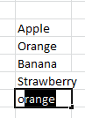

From there you need to;

1. Press enter to accept
2. Continue typing to input something different
3. Press backspace to cancel Auto Complete.

**2. Explain working with workbooks and working with cells.**

**Ans:**

* **Cells** -

A cell is an essential part of MS-Excel. It is an object of Excel worksheets. Whenever you open Excel, the Excel worksheet contains cells to store the information in them. You enter content and your data into these cells. Cells are the building blocks of the Excel worksheet. In the Excel worksheet, a cell is a rectangular-shaped box. It is a small unit of the Excel spreadsheet. There are around 17 billion cells in an Excel worksheet, which are united together in horizontal and vertical lines.

An Excel worksheet contains cells in rows and columns. Rows are labeled as numbers and columns as alphabets. It means the rows are identified by numbers and columns by alphabets.

* **Workbooks** -

A workbook is a collection of one or more spreadsheets, also called worksheets, in a single file. Below is an example of a spreadsheet called "Sheet1" in an Excel workbook file called "Book1." Our example also has the "Sheet2" and "Sheet3" sheet tabs, which are also part of the same workbook.

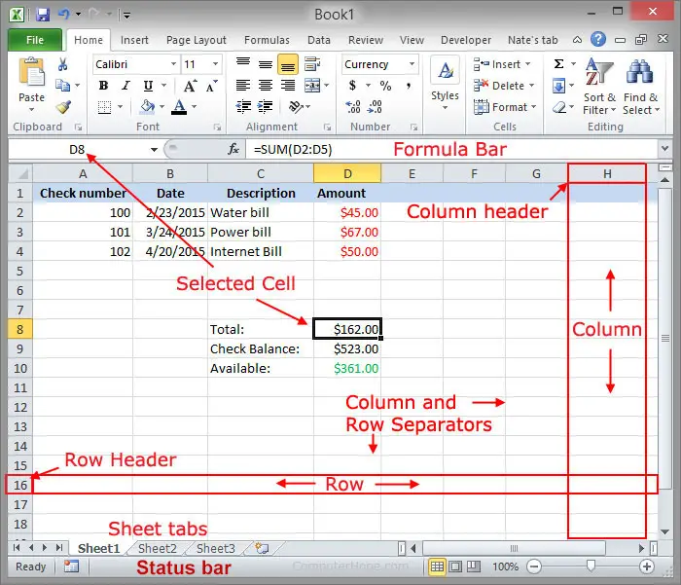

* Difference between a workbook, worksheet, and spreadsheet

Because the terms spreadsheet, workbook, and worksheet are so similar, there may be some confusion when trying to understand their differences. When you open Microsoft Excel (a spreadsheet program), you're opening a workbook. A workbook can contain one or more different worksheets that can be accessed through the tabs at the bottom of the worksheet your currently viewing. What's often most confusing is that a worksheet is synonymous with a spreadsheet. In other words, a spreadsheet and worksheet mean the same thing. However, most people only refer to the program as a spreadsheet program and the files it creates as spreadsheet files.

**3. What is fill handle in Excel and why do we use it?**

**Ans:**

The Fill handle is an Excel feature that is used to fill the data automatically with a specific pattern. You can extend a series of numbers, dates and text combinations to the desired number of cells.

Fill handle is a versatile tool in the excel suite that autocompletes various entries, transforms the data, and several other applications. It is an inbuilt excel feature that is enabled by default and therefore does not involve any manual procedure to implement it.

To use the fill handle, move your mouse pointer to the right bottom corner of the cell; it will change into a tiny + (cross) sign. Drag the cross sign, and if Excel recognizes the pattern, it will autofill the cells with the updated data. Else it will copy the same data in all the dragged cells. 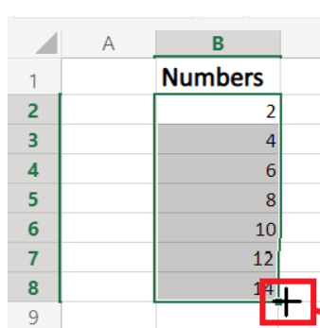

**4. Give some examples of using the fill handle.**

**Ans:**

1. Autofill Weekday Names

Entering the list of days in excel is one of the common operations performed by every user. You can quickly fill the week names using the Fill Handle feature. Type the weekday and by using + sign drag till A7 like shown below

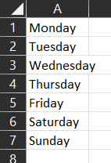

1. Autofill Dates

Dates are also commonly used in our day-to-day excel life. Therefore using the Fill handle, you can easily autofill dates in your spreadsheet.

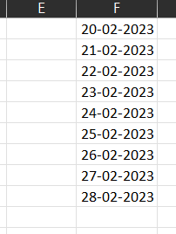

some widely used Fill Handle options below:

1. **Copy Cells**: This option simply copy-pastes the value of the selected cells.
2. **Fill Series**: This option fills the cells as a series with increments of 1.
3. **Fill Formatting Only**: This option only fills the formatting in the cells rather than values.
4. **Fill without Formatting**: This option fills the cells based on the value pattern without copying the formatting.
5. **Fill Days**: This option fills the cells with a series of days’ names.
6. **Fill Weekdays**: This option fills the cells with the days’ names except for the weekends (Sat and Sun).
7. **Fill Months**: This option creates the list by incrementing the months only and the date and year remain constant.
8. **Fill Years**: This option creates the list by incrementing the years only and the date and month remain constant.

**5. Describe flash fill and what the different ways to access the flash fill are.**

**Ans:**

Flash Fill is a feature in Microsoft Excel that automatically fills in values based on patterns it recognizes in the data. It can be useful for tasks such as splitting or combining data, formatting data, and converting data to a different format. Here are some different ways to access Flash Fill in Excel:

* Using the Ribbon: Click on the "Data" tab in the Ribbon, and then click on the "Flash Fill" button in the "Data Tools" group.
* Using the keyboard shortcut: Press **Ctrl + E** on your keyboard to activate Flash Fill.

**6. Extract first name and last name from the mail id and then from the address column, extract the city, state, and pin code using the flash fill. Given below is an example of the columns you have to create. Paste the screenshot of what you have created using the flash fill command.**

**Ans:**

